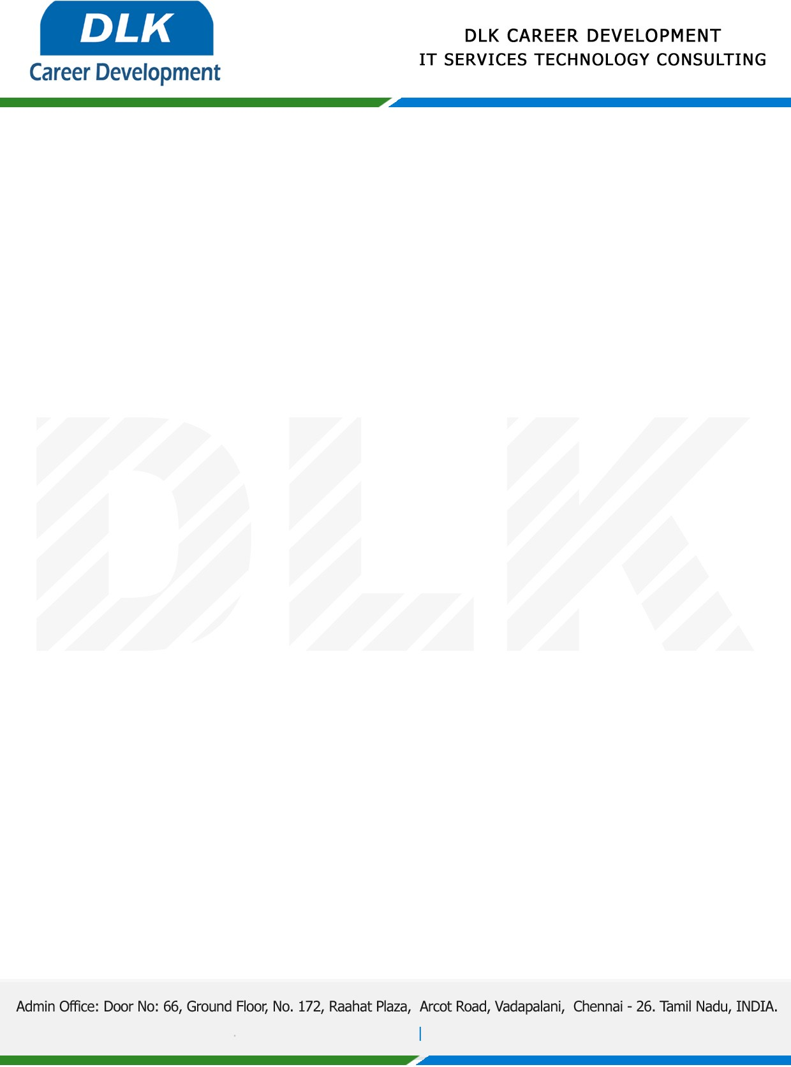

Date: 27 /February / 2023

**To**

Department of B.E (Electronics and Communications Engineering),

Head of Department,

Sri Venkateswara College of Engineering(Sriperumbudur)- 602117.

**Sub: Letter of Internship Acceptance**

This is to certify that **MS HARIPRIYA K G (REG NO:** **2127200701042)** third year student of has accepted the internship Work duration from **06th March 2023** to **19th March 2023** under the domain **“Python”.** During the internship , all information and data collected from you should be kept confidential.

We appreciate your interest in **DLK CAREER DEVELOPMENT**

